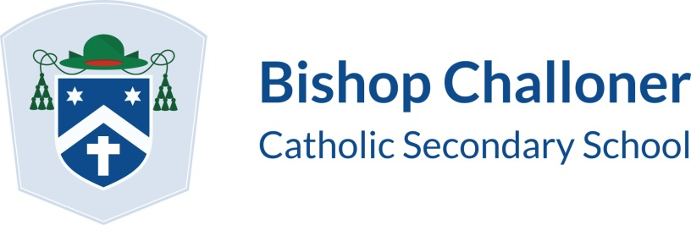
Diocese of Portsmouth
St. Michael’s Road, Basingstoke, Hampshire RG22 6SR
Tel: (01256) 462661 Fax: (01256) 810359
email: headteacher@bcs.hants.sch.uk
website: www.bcs.hants.sch.uk
Headteacher: Mr J P Wright, BTh

Dear Parent/Carer

As you will be aware from our school calendar, the Year 11 Parents’ Evening will be held on Tuesday 30 January 2018.

Appointments will start at 4:45pm and finish at 7:00pm. Each appointment should last for 5 minutes; if additional time is needed, then a separate arrangement can be made with the individual teacher concerned.

Please encourage your child to obtain as many appointments as possible. If there is a specific period of time you would prefer your appointments to fall within, we suggest you communicate this clearly to your child before they begin making individual appointments for you.

Please may I remind you that this is an important opportunity to discuss your child’s mock examination results and the strategies which need to be put in place to ensure success in the summer. You are strongly advised to attend this event. If you are unable to attend, please advise us of this in advance.

Yours sincerely

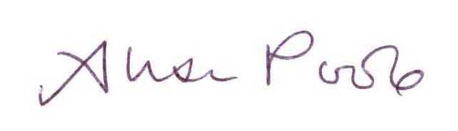
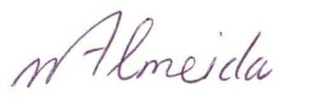

J P Wright Mrs Almeida & Mrs Poole
Headteacher Heads of Year 11

