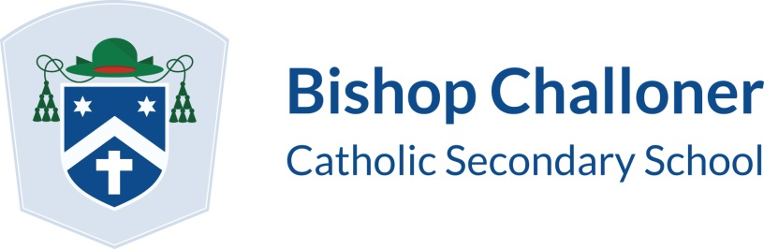

Year 11 February 2018 Half-Term Revision Schedule
 | Monday 12th | Tuesday 13th | Wednesday 14th | Thursday 15th
10:00 – 14:00 | Mrs Smith – Music  Mr Newman-Farr  Mr Gough - RM | Mrs Smith – Music  Mrs Cottam  Mr Letherby – Chemistry/Physics | Mrs Cottam  Mrs Morley - Library | Mrs Morley – Library  Mrs Cripps - RE

Students must sign in/out at the main office using the Inventry system. Trips to One-Stop or other local shops are prohibited. Please bring in your own food/lunch.

You must be in supervised workshops for the duration of your time at school (as specified above) and toilets are accessible. All other rooms and areas within the school are not accessible and are off limits. Floating around the school is not an option. Revision is the main priority.

General revision will commence after the February Half-Term, the first session being Saturday 24th February. Further dates are advertised on the website.

